
Laufenberg Meats

6973 Riles Rd Waunakee WI, 53597

Processing@laufenbergmarket.com
Processed by Roskum Meats
Luke Laufenberg 608-438-9958

-

BEEF CUTTING INSTRUCTIONS

Please circle your order request.
Size | Type | Down Payment
Whole |  | $600
Half | Split Front Hind | $300
Quarter | Split Front Hind | $150

Front Quarter (circle your choices)
Chuck Roast | 2# or 3# or 4# NONE
Arm Roast | 2# or 3# or 4# NONE
Soup Bones | Yes or No
Rib Eye Steaks ¾” or 1” | 2, 3, or 4 per pkg
Short Ribs | Yes or No
Hind Quarter
T-Bone/Porterhouse Steaks(bone-in) | ¾”, or 1”thick | 2, 3, or 4 per pkg
OR (choose only one)
Tenderloin/New York Strip(boneless) | ¾”, or 1” thick | 2, 3, or 4, per pkg

Round Steak | Regular or Tenderized Cut |  | ½” or ¾” thick ; 1 per pkg
 | Stew Meat |  | 1#, 1.5#, 2#, or 3# pkg
 | Cube Steak |  | 2, 3, 4 per pkg
 | Dried Beef (1#pkgs) or Jerky (1/2# pks)
 | Trim | will be put with ground beef
Rump Roast/ Rolled Rump |  |  | 2#, 3# or 4# NONE
Sirloin Steak | ¾”, or 1” thick |  | 1 per pkg
Trimmings: Choose what percentage or pounds of trimmings you want in ground beef or in patties (Examples: 2/3 hamb. & 1/3 patties OR 30# patties & rest hamb.)
Ground Beef _____ ( tubes ___or freezer wrapped___) | 1#, 1.5# or 2#,
Patties _____ ( how many per pkg ____ OR 10# boxes ____) | 1/3 lb. or 1/4 lb. burgers
Miscellaneous – circle if wanted:
Tongue, Heart, Liver, Suet, Oxtail, Flank Steak, Skirt Steak, Brisket (wh or cut in ½)

Processing costs:
Processing Fee = $5.49 4.99/lb (cut, vacuumed sealed, freeze) Grass-finished = $6.49/lb Tenderizing = $1.00/lb Patties = $0.85/lb Stew Meat = $1.00/lb Dried Beef = $2.25/lb Jerky = $4.25/lb
Prices may change without prior notice. A down payment is required for custom orders on the date of ordering. We prefer cash or check. When picking up orders, payment can be made with cash, check, or credit card. A 4% service fee applies to all transactions. Name_______________________________Phone_____________________________________
Address_______________________________________________________________________
Email: ________________________________________________________________________
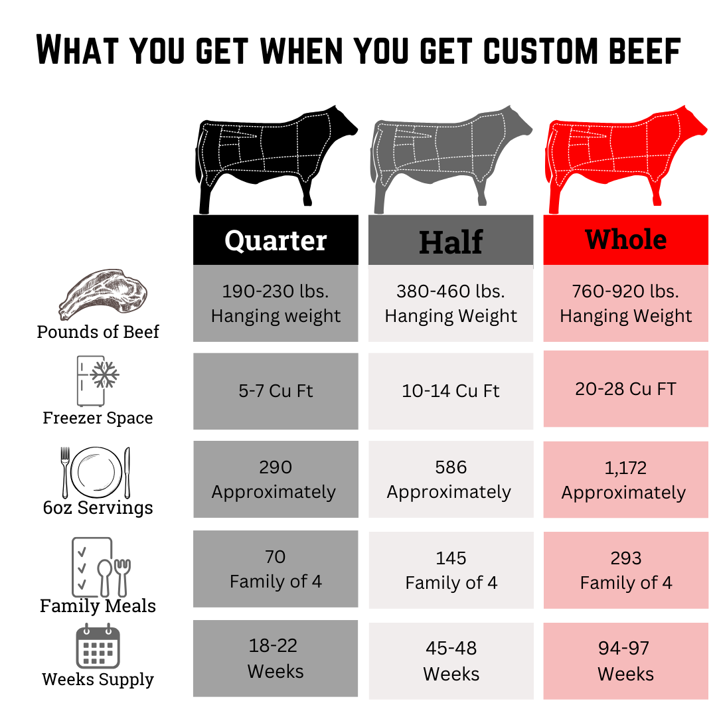
Other instructions_______________________________________________________________

